Computer Practical
File

2025-‘26

Name: Ved Kapadia

INDEX
S.no | Program name | Pg no.
 |  | 1
1. | Input a welcome message and display it | 1
2. | Perimeter and area of a circle | 1
3. | Input three numbers and display largest/smallest number | 2
4. | Write a program to check entered number is odd or even | 4
5. | Write a program to check entered character is a vowel | 5
6. | Write a program to check entered character is vowels, consonants, uppercase, lowercase or special character | 6
7. | A telephone company charges for using telephone from their consumers according to the calls made (per month) as per the given tariff:  Numbers of calls Charge  Up to 50 calls No charge (free)  For next 100 calls exceeding 50 call Rs. 2 per call  For next 200 calls exceeding 150 call Rs. 1.50 per call + Previous 100 calls bill amount  More than 350 calls Rs. 1 per call + Previous 200 calls bill amount + previous 100 calls bill amount | 7
8. | Write a program to input the value of x and n and print the sum of the following series | 8
9. | To print first three multiples of entered number. | 9
10. | Input two integers x and n, compute x^{n}. | 10
11. | Accept a decimal number and print its binary. | 11
12. | Accept a decimal number and print its octal. | 12
13. | Remove vowels from string. | 13
14. | Check string is palindrome or not | 14
15. | Read a line and capitalize the first letter of each word and form a new string. | 15
16. | Read a string and display longest substring. | 16
17. | Count number of words in a line. | 17
18. | Read a line and count how many time “to” appear in line. | 18
19. | Add 5 in odd values of a list and add 10 in even values of list. | 29
20. | Write a program to demonstrate Linear Search(search an element present in list using loop) | 20
21. | Display frequencies of all elements of a list. | 21
22. | Find the largest/smallest number in a list elements at the odd location. | 22
23. | Create a tuple containing the squares of the integers in given range. | 23
24. | Create a nested tuple to store marks of three subject for 5 students print total marks and average of each student. | 24
25. | Area and perimeter of circle/triangle/square/rectangle.(give choice) | 25
26. | Convert Length Centimeter to inches and inches to centimeter.(give choice) | 27
27. | Create a dictionary, to input n names and phone numbers to store it in a dictionary and print the phone number of a particular name. | 28
28. | Create a dictionary, to input n names and phone numbers to store it in a dictionary and print the phone number of a particular name. | 29

Program #1- Input a welcome message and display it.

Code:-
# Input a welcome message and display it.
a=input("Write a welcome message")
print(a)
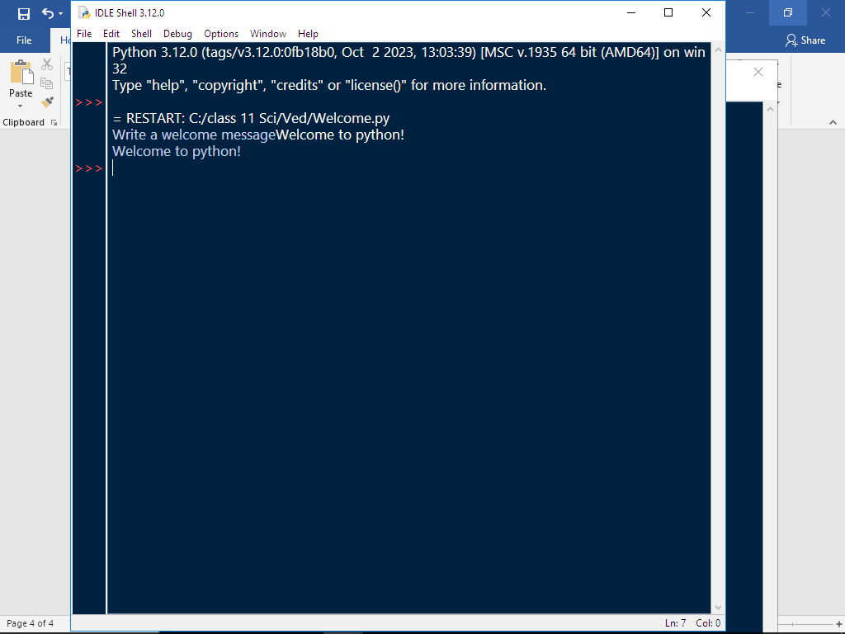

Program #2-

PERIMETER AND AREA OF A CIRCLE

Code:-

# PERIMETER AND AREA OF A CIRCLE
r=eval(input('enter radius of circle'))
cir=2*22/7*r
print('Perimeter of given circle is', cir)
ar=22/7*r**2
print('Area of given circle is', ar)

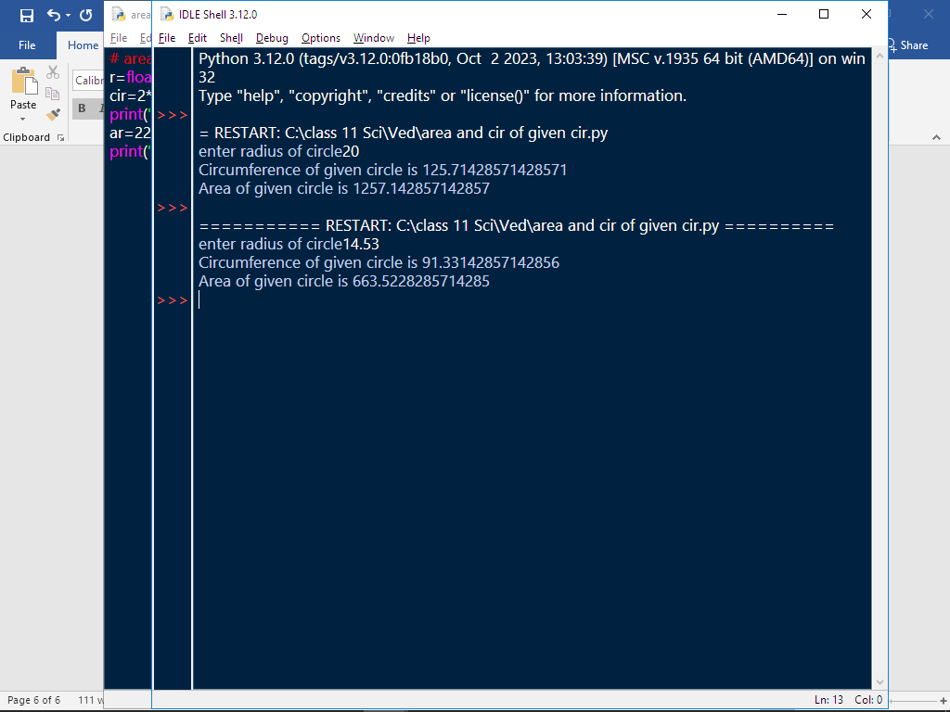

Program #3-

Input three numbers and display the largest / smallest number.

Code:-

a=int(input("Enter no. 1"))
b=int(input("Enter no. 2"))
c=int(input("Enter no. 3"))
if a<b and a<c:
print(a, "is smallest")
elif b<a and b<c:
print(b, "is smallest")
elif c<a and c<b:
print(c, "is smallest")
elif a<=b and a<c:
print("first and second are smallest")
elif b<a and b<=c:
print(" second and third are smallest")
elif a<=c and a<b:
print(" first and third are smallest")
elif a==b and a==c:
print("all no's are equal")

if a>b and a>c:
print(a, "is biggest")
elif b>a and b>c:
print(b, "is biggest")
elif c>a and c>b:
print(c, "is biggest")
elif a>=b and a>c:
print("first and second are biggest")
elif b>a and b>=c:
print(" second and third are biggest")
elif a>=c and a>b:
print(" first and third are biggest")
elif a==b and a==c:
print("all no's are equal")

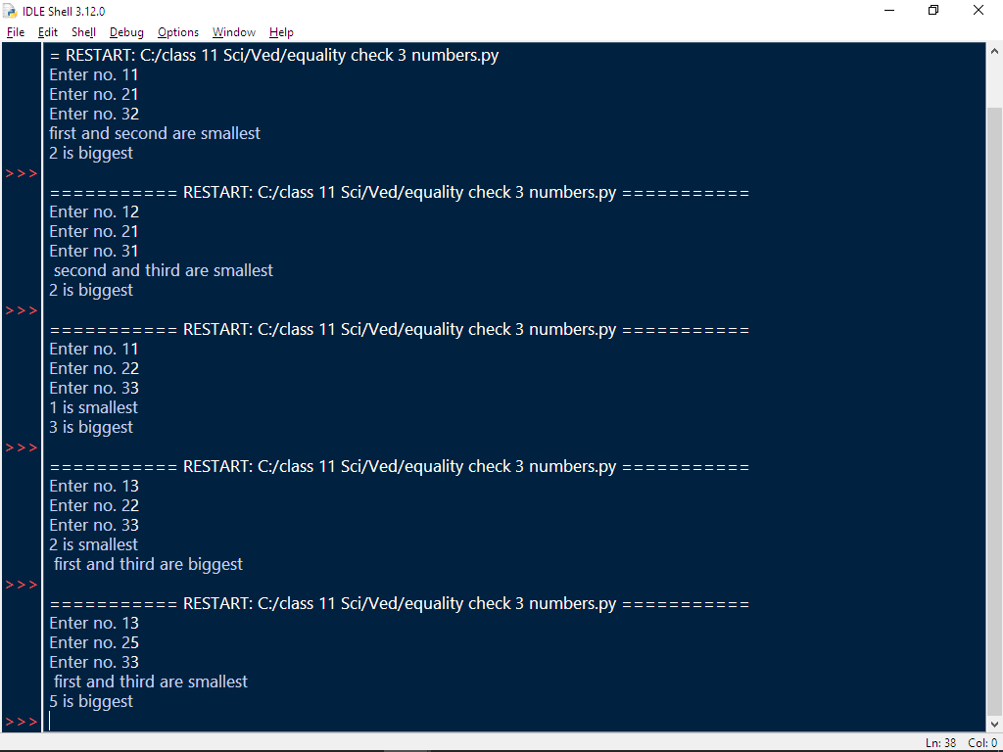

Program #4-
Write a program TO CHECK ENTERED NUMBER IS ODD /EVEN.

Code:-

a=int(input("Enter a number"))
if a%2==0:
print("Number is even")
else:
print("Number is odd")

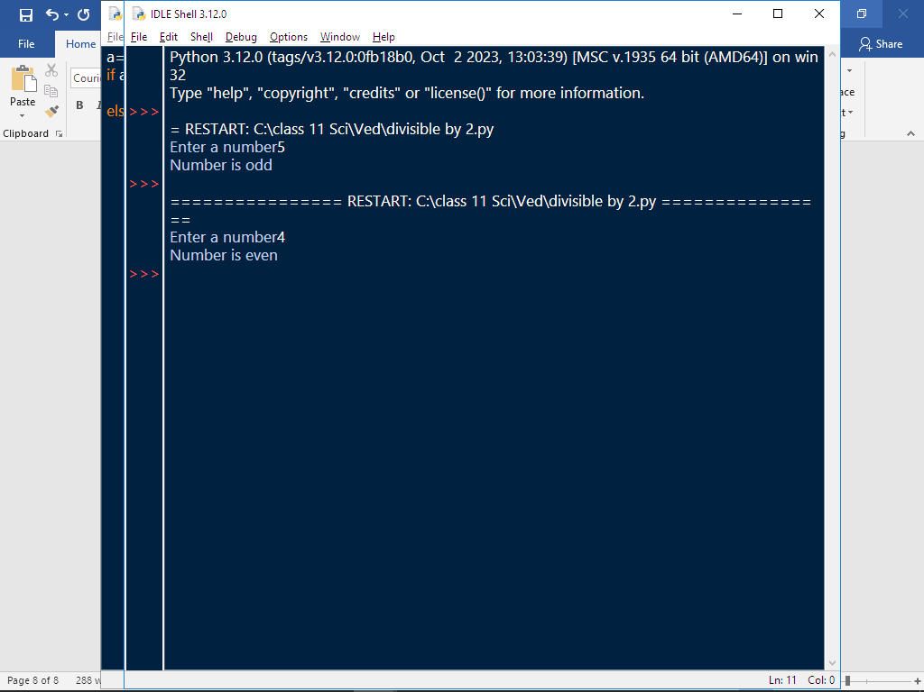

Program #5- Write a program to check for LEAP YEAR

Code:-

a=int(input("Enter your year in 4 digits"))
if a>999 and a<10000:
if a%4==0:
print("It is a leap year")
else:
print("It is not a leap year")
else:
print("You entered invalid year")

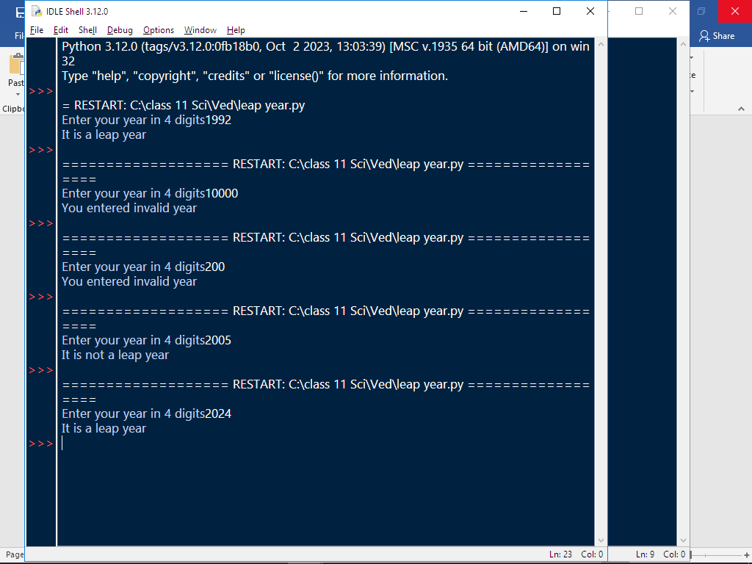

Program #6-
Write a program to check entered character is vowels, consonants, uppercase, lowercase, special characters.

Code:-

a=input("Enter anything")
if a>="A" and a<="Z":
if a=="A" or "E" or "I" or "O" or "U":
print("vowel, uppercase")
else:
print("consonant, uppercase")
elif a>="a" and a<="z":
if a=="a" or "e" or "i" or "o" or "u":
print("vowel, lowercase")
else:
print("consonant, lowercase")
elif a>="0" and a<="9":
print("digit")
else:
print("special character")

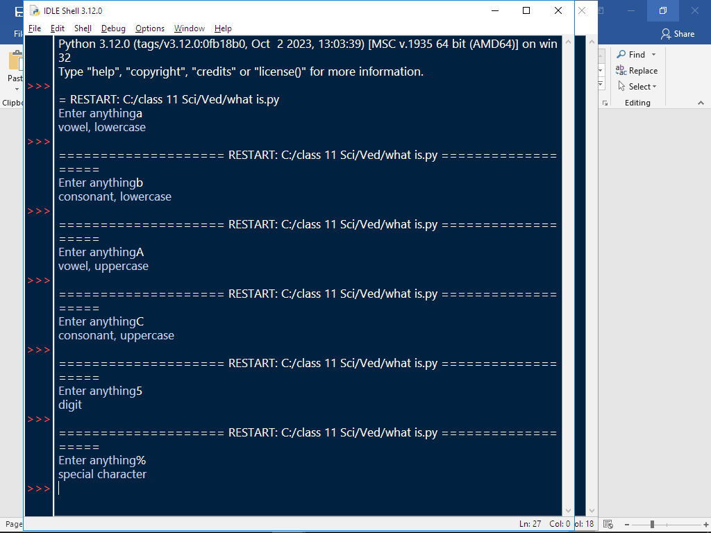

Program #7-

A telephone company charges for using telephone from their consumers according to the calls made (per month) as per the given tariff:

Numbers of calls Charge
Up to 50 calls No charge (free)
For next 100 calls exceeding 50 call Rs. 2 per call
For next 200 calls exceeding 150 call Rs. 1.50 per call + Previous 100 calls bill amount
More than 350 calls Rs. 1 per call + Previous 200 calls bill amount + previous 100 calls bill amount

Code:-
n=int(input("Enter no. of calls made"))
if n<0:
print("You have entered wrong number of calls, please enter correct value")
elif n<=50:
print("Your bill is free")
elif n<=150:
n=n-50
n=n*2
print("Your bill is",n)
elif n<=350:
n=n-150
b=n*1.5+200
print("Your bill is",b)
elif n>350:
n=n-350
b=300+200+n
print("Your bill is",b)

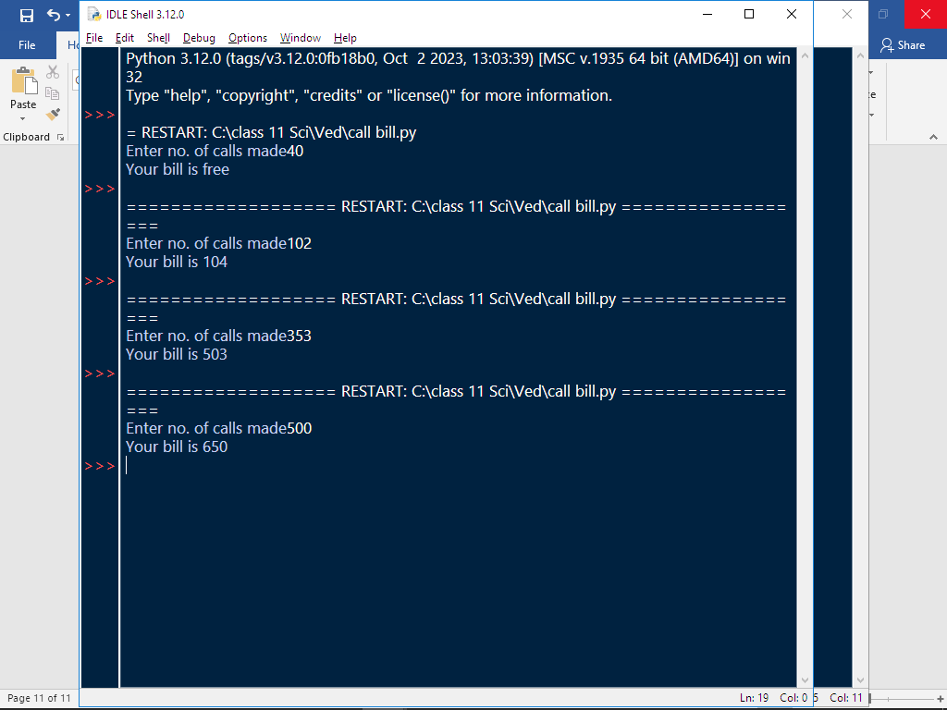

Program #8-
Write a program to input the value of x and n and print the sum of the following series:
Code:-
n=int(input("Enter value of n"))
x=int(input("Enter value of x"))
a=1
for b in range(2,n+1):
a=a+x**b
print("Sum of series=",a)

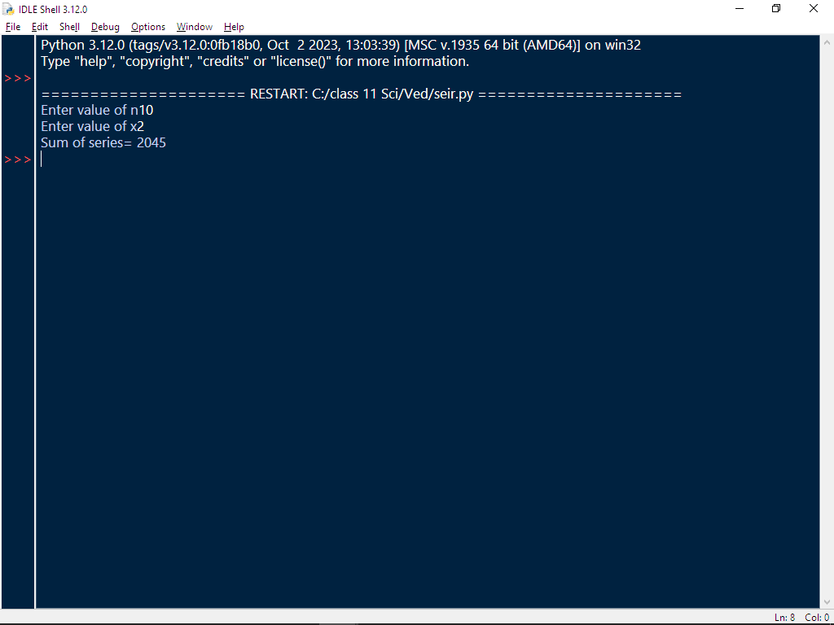

Program #9-

To print first three multiples of entered number.

Code:-

x=int(input("Enter your number"))
print("First 3 multiples of",x,"are->",x,x*2,x*3)

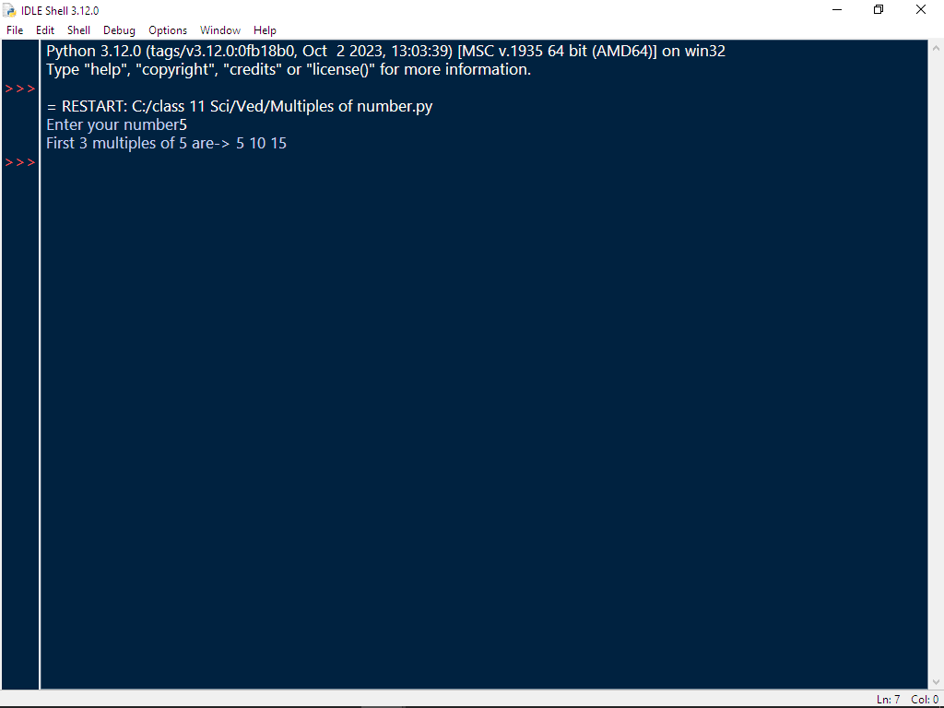

Program #10-

Input two integers x and n, compute x^{n}.

Code:-

x=int(input("Enter the number"))
n=int(input("Enter the power"))
print(x**n)
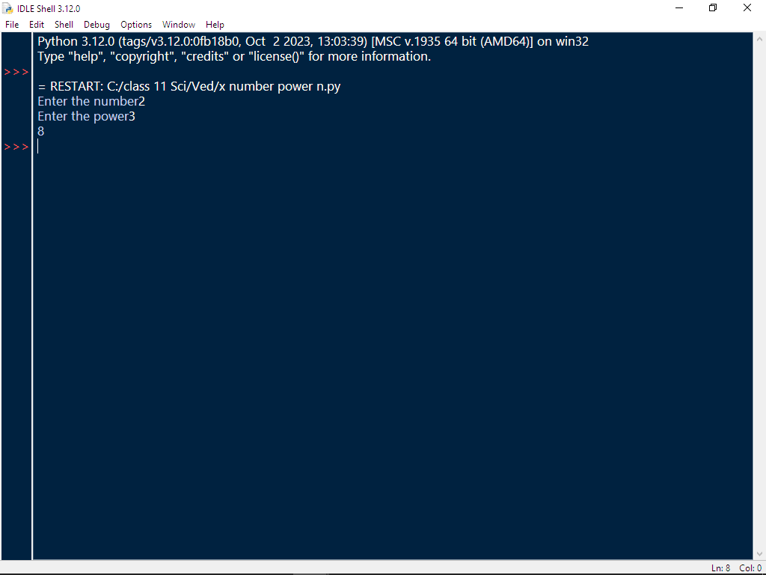

Program #11-

Accept a decimal number and print its binary.

Code:-

n = int(input("Enter a number"))
b = ""
while n > 0:
b = str(n % 2) + b
n = n // 2
print(b)

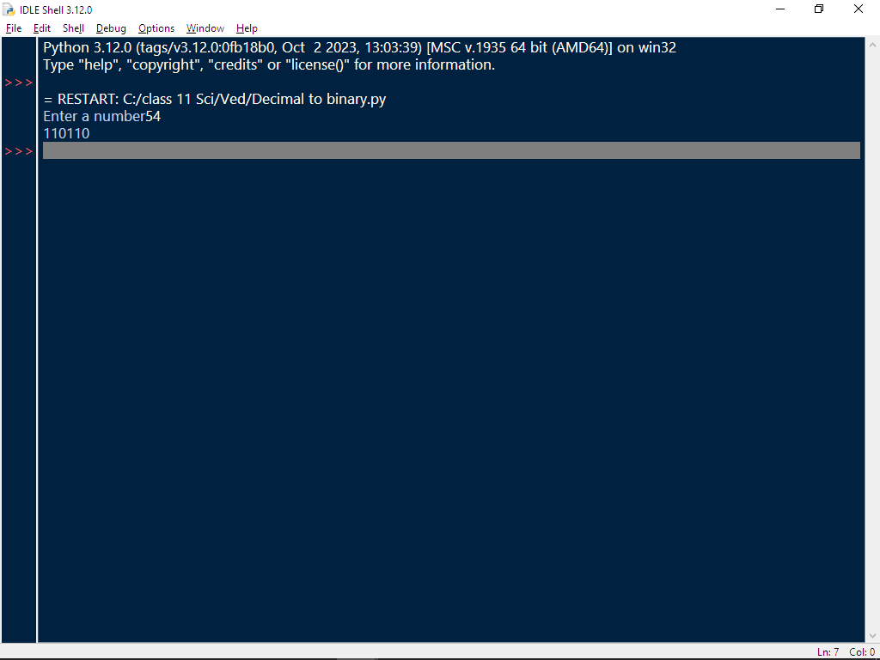

Program #12-

Accept a decimal number and print its octal.

Code:-

n = int(input("Enter a number: "))
o = ""
while n > 0:
o = str(n % 8) + o
n = n // 8
print(o)

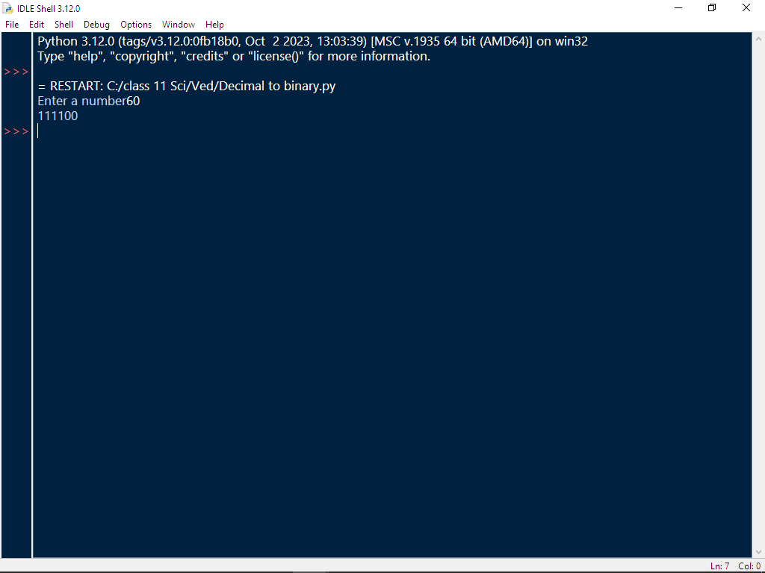

Program #13-

Remove vowels from string.

Code:-

a=input("Enter a string")
b=""
for i in a:
if i not in "aeiouAEIOU":
b=b+i
print(b)

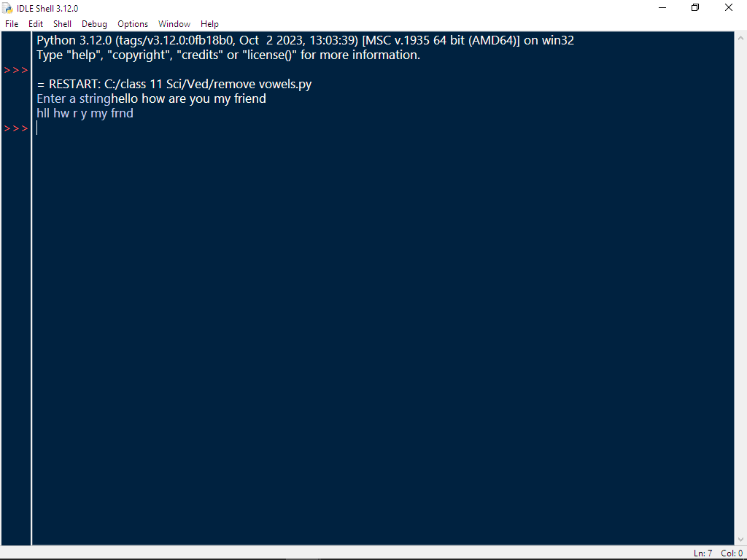

Program #14-

Check string is palindrome or not.

Code:-

a=input("Enter a string")
b=''
for i in range(-1,-1*len(a)-1,-1):
b=b+a[i]
if b==a:
print("Pallindrome")
else:

print("Not pallindrome")

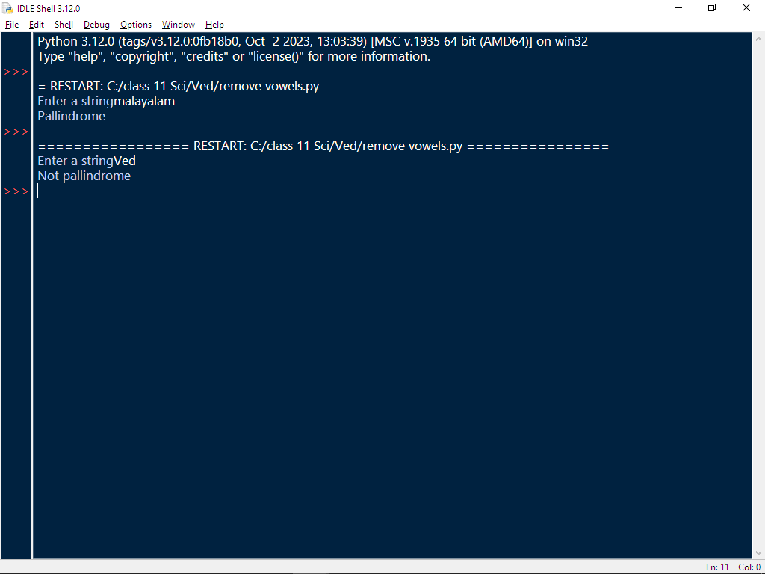

Program #15-

Read a line and capitalize the first letter of each word and form a new string.

Code:-

a=input("Enter a string")
b=a.title()
print(b)

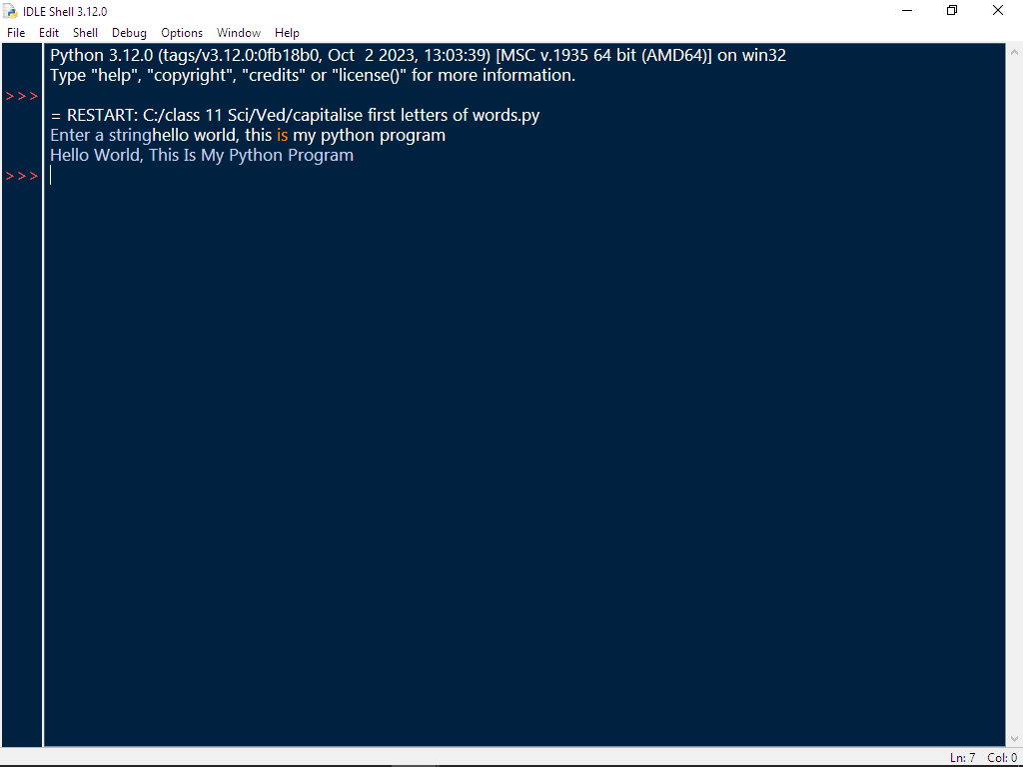

Program #16-

Read a string and display longest substring.

Code:-

a=input("Enter a string")
b=a.split()
c=''
for i in b:
if len(i)>=len(c):
c=i
print(c)

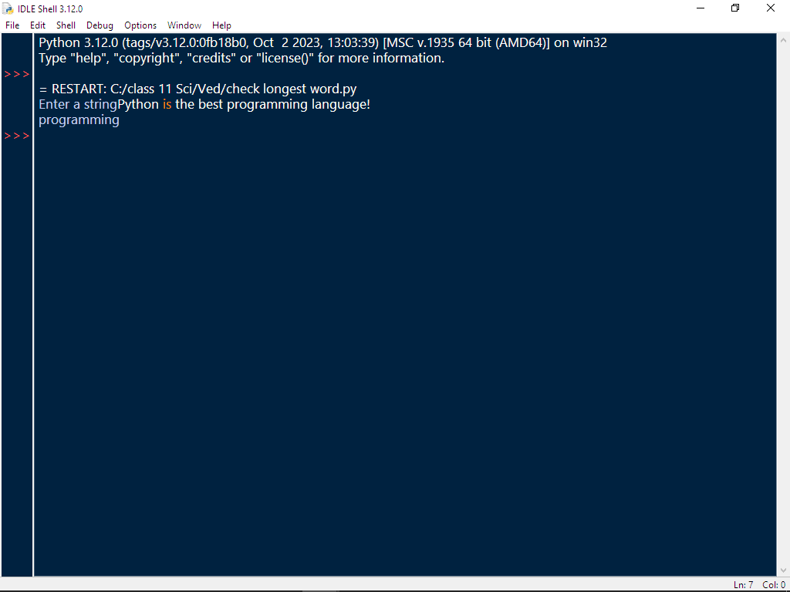

Program #17-

Count number of words in a line.

Code:-

a=input("Enter a string")
b=a.split()
print("Number of words is", len(b))

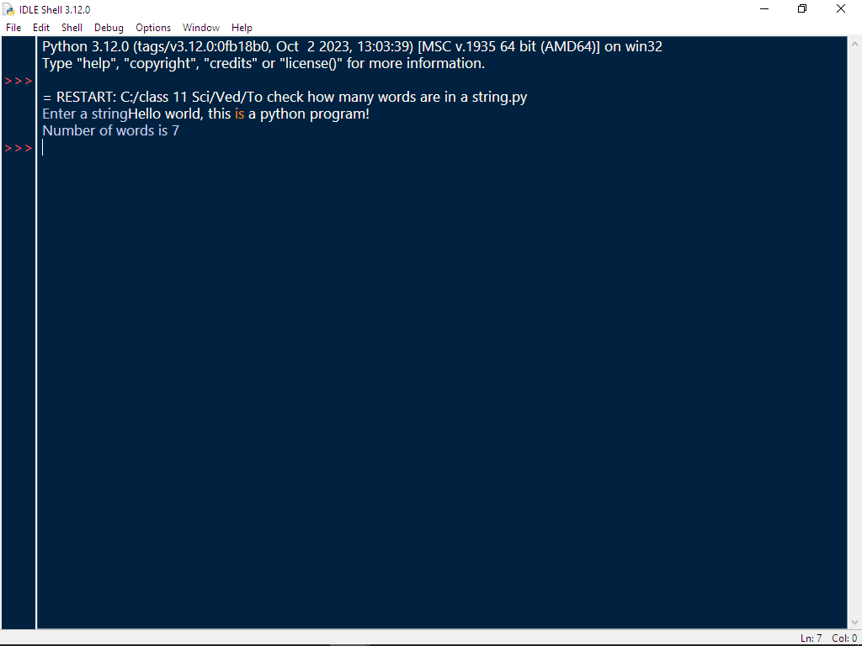

Program #18-

Read a line and count how many time “to” appear in line.

Code:-

a=input("Enter a string")
b=a.split()
print("Number of times to appears is", b.count("to"))

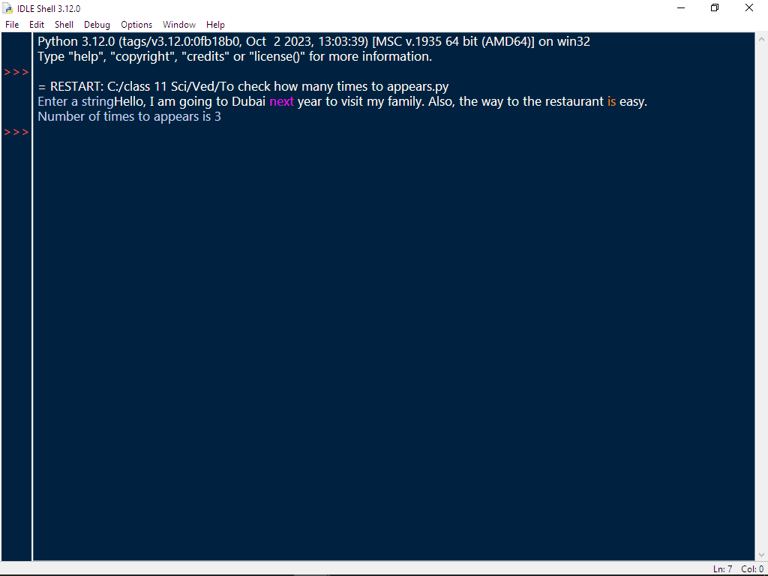

Program #19-

Add 5 in odd values of a list and add 10 in even values of list.

Code:-

a=eval(input("Enter a list"))
for i in range(len(a)):
if a[i]%2==0:
a[i]=a[i]+10
else:
a[i]=a[i]+5
print(a)
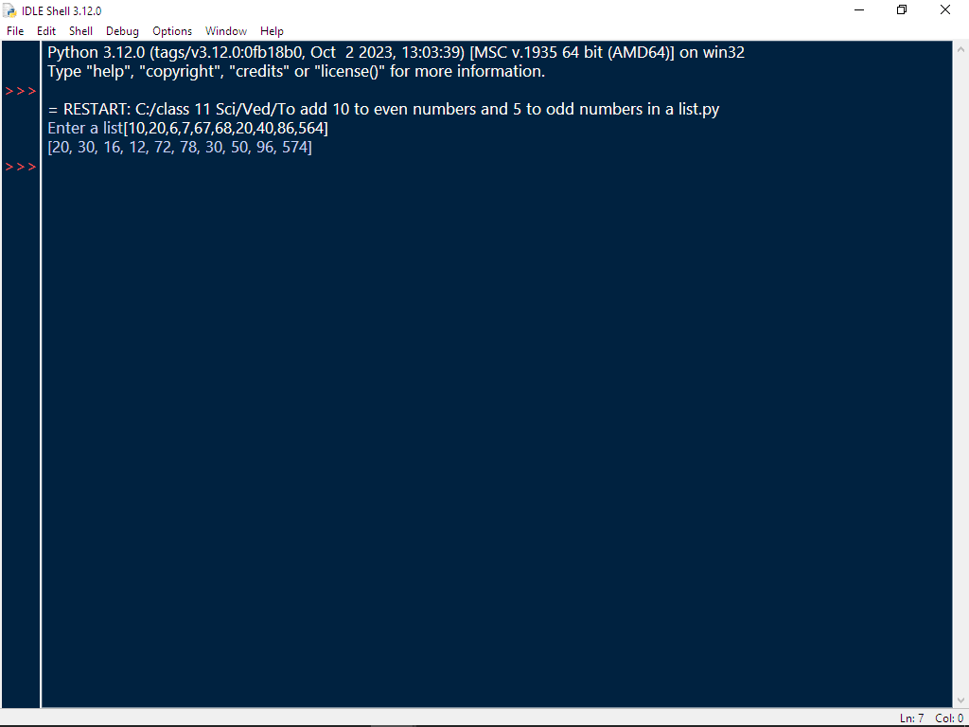

Program #20-

Write a program to demonstrate Linear Search(search an element present in list using loop)

Code:-

a=input("Enter a string")
b=a.split()
c=input("Enter what you want to check in the string")
for i in b:
if c==i:
print('"',c,'"',"is present in the entered string")
break
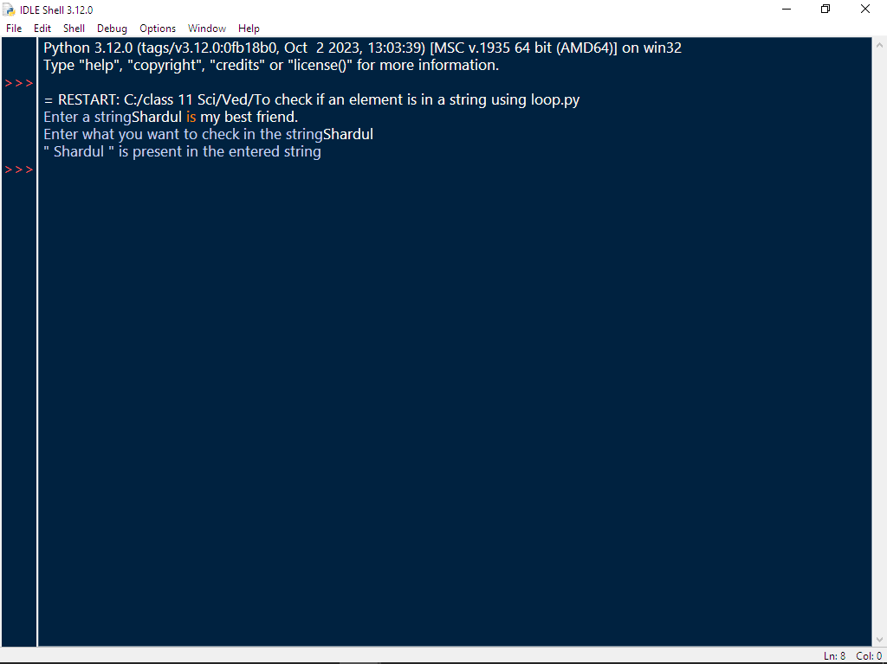

Program #21-

Display frequencies of all elements of a list.

Code:-

a=eval(input("Enter a list"))
for i in a:
print(i,"occurs",a.count(i),"times")

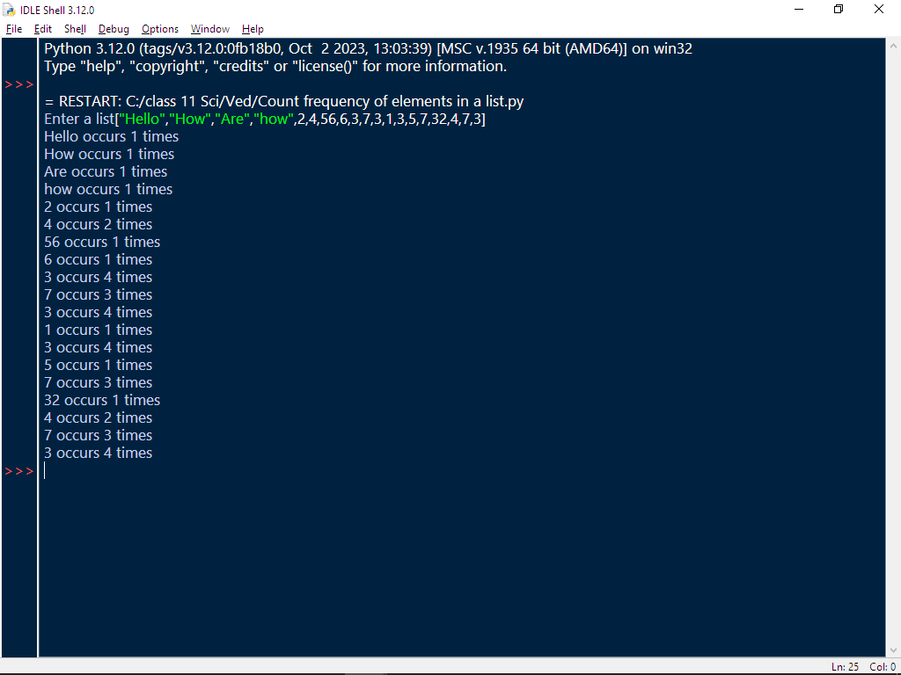

Program #22-

Find the largest/smallest number in a list elements at the odd location.

Code:-

a=eval(input("Input a numeric list"))
b=[]
for i in range(1,len(a),2):
b.append(a[i])
c=0
d=0
for j in b:
if j>=c:
c=j
print(c)
for k in b:
if k<=c:
c=k
print(c)

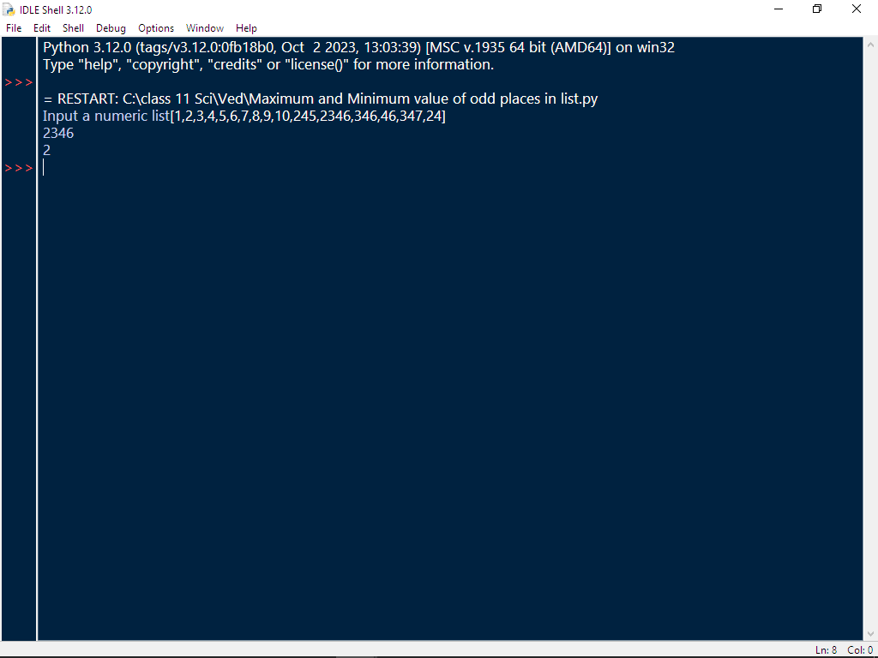

Program #23-

Create a tuple containing the squares of the integers in given range.

Code:-

a=()
b=int(input("Enter start value"))
c=int(input("Enter stop value"))
for i in range(b,c+1):
a+=(i**2,)
print(a)

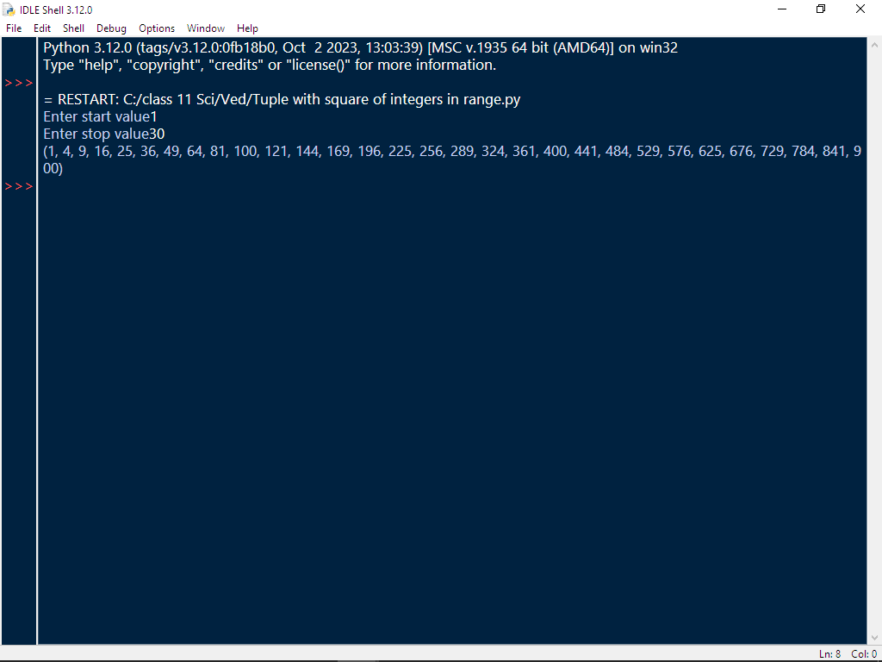

Program #24-

Create a nested tuple to store marks of three subject for 5 students print total marks and average of each student.
Code:-
f=()
for i in range(5):
a=input("Enter student name")
b=int(input("Enter marks of subject 1"))
c=int(input("Enter marks of subject 2"))
d=int(input("Enter marks of subject 3"))
e=(a,b,c,d)
f=f+(e,)
total=0
for j in f:
total=j[1]+j[2]+j[3]
print(j[0],"->total marks:",total)
print(j[0],"-> average marks:",total/3)
total=0
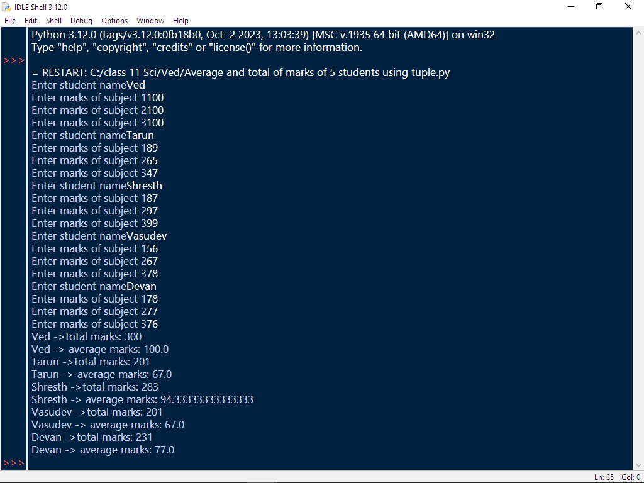
Program #25-

Area and perimeter of circle/triangle/square/rectangle.(give choice)

Code:-
n=1
z="yes"
while n>0:
if z.lower()=="yes":
a=input("Enter a shape you want to find area and perimeter of->(circle/triangle/square/rectangle)")
if a.lower()=="circle":
b=int(input("Enter the radius of circle"))
print("Perimeter is->",b*2*22/7)
print("Area is->",b*b*22/7)
elif a.lower()=="triangle":
b=int(input("Enter first side of triangle"))
c=int(input("Enter second side of triangle"))
d=int(input("Enter third side of triangle"))
s=b+c+d/2
area=(s*(s-b)*(s-c)*(s-d))**(1/2)
print("Perimeter is->",b+c+d)
print("Area is->",area)
elif a.lower()=="square":
b=int(input("Enter side of square"))
print("Perimeter is->",4*b)
print("Area is->",b**2)
elif a.lower()=="rectangle":
b=int(input("Enter length"))
c=int(input("Enter breadth"))
print("Perimeter is->",2*(b+c))
print("Area is->",b*c)
else:
print("Wrong shape")
z=input("Would you like to continue? (yes/no)")
else:
n=0
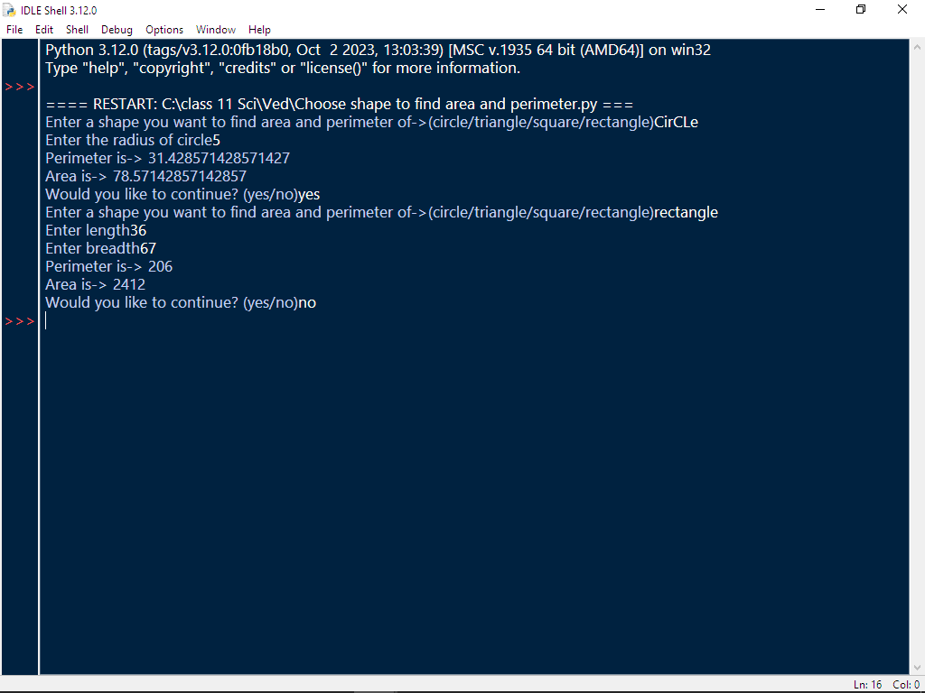

Program #26-

Convert Length Centimeter to inches and inches to centimeter.(give choice)

Code:-

a=input("Do you want to convert from centimetre to inch(in) or inch to centimetre(cm)?")
if a.lower()=="in":
b=int(input("Enter your value in centimetre"))
print(b,"centimetres to inches is:",b/2.54,"inches")
elif a.lower()=="cm":
b=int(input("Enter your value in inches"))
print(b,"inches to centimetres is:",b*2.54,"centimetres")

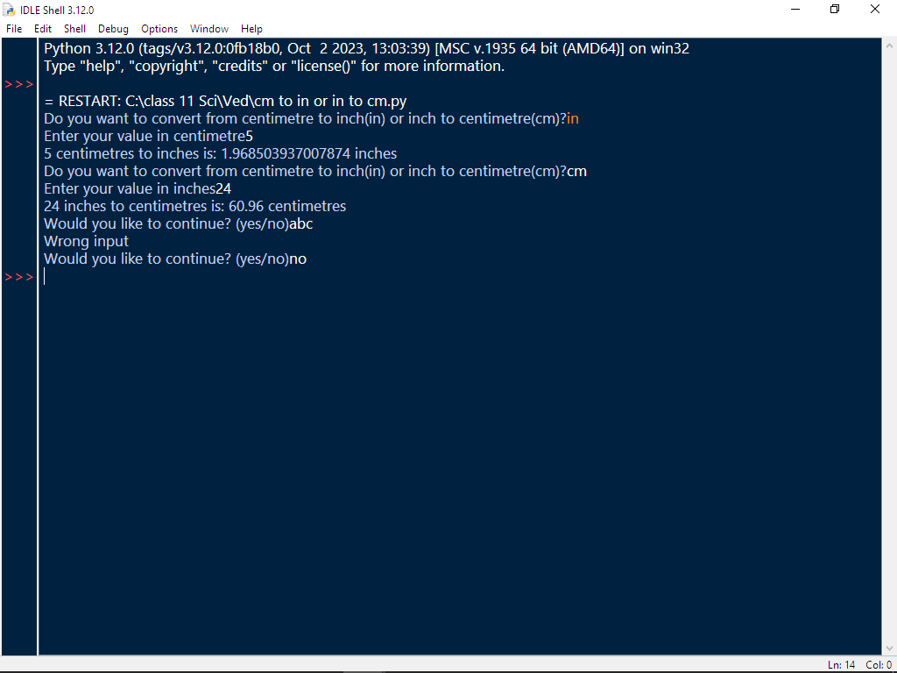

Program #27-

Create a dictionary, to input n names and phone numbers to store it in a dictionary and print the phone number of a particular name.

Code:-

d={}
n=int(input("Enter how many names"))
for i in range(n):
a=input("Enter the name")
b=int(input("Enter phone number"))
d1={a:b}
d.update(d1)
m=input("Enter name of person whose phone number you want")
print(d[m])
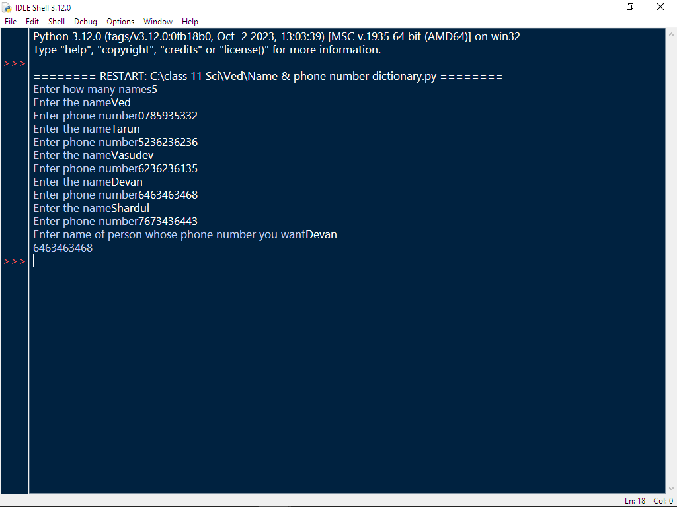

Program #28-

Create a dictionary, to input n names and phone numbers to store it in a dictionary and print the phone number of a particular name.

Code:-

d={}
n=int(input("Enter how many classes"))
for i in range(n):
a=input("Enter the class")
b=input("Enter name of class teacher")
d1={a:b}
d.update(d1)
print("Your dictionary is->", d)
m=input("Enter class whose class teacher you want")
print(d[m])

